# Testing Lab 2: Snapshot Tests

## Objectives

*  Install React's Test Renderer
*  Create Your First Snapshot Test

## Steps

### Install React's Test Renderer

1. **Open** a command prompt (Windows) or terminal (Mac).
2. Change the **current directory** to keeptrack.
3. **Run**  the following command:

#### npm

npm i react-test-renderer --save-dev

### Create Your First Snapshot Test

1. Add a snapshot test for the component. Organize the tests in a suite (describe function).

#### src\home\HomePage.test.js

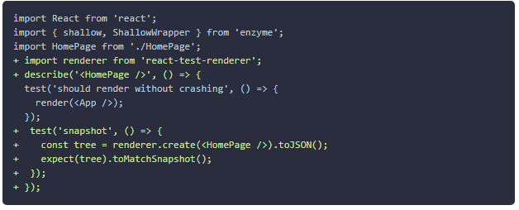

1. Verify the snapshot is created.

› 1 snapshot written.

1. **Open** src\home\__snapshots__\HomePage.test.js.snap and review the contents.
2. Wrap your tests in a describe block to create a test suite.

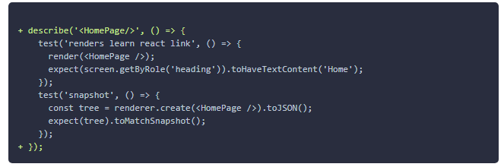

### ✔ You have completed Testing Lab 2